**（a）Fully Supervised Work**

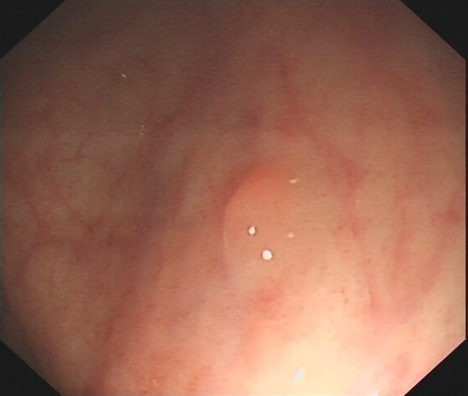

**Image**

**Class**

**Xmin**

**Ymin**

**Xmax**

**Ymax**

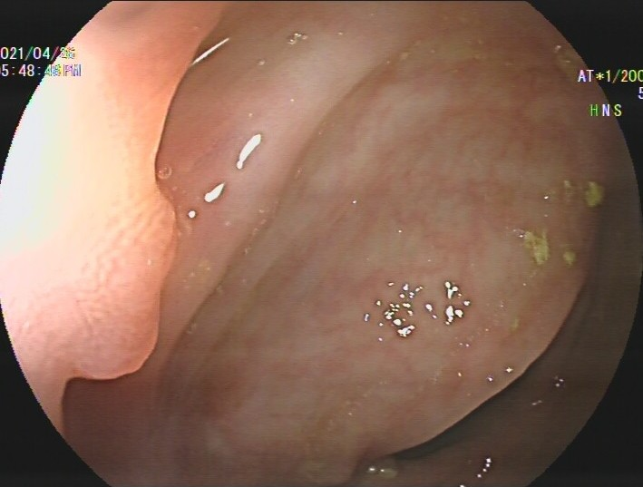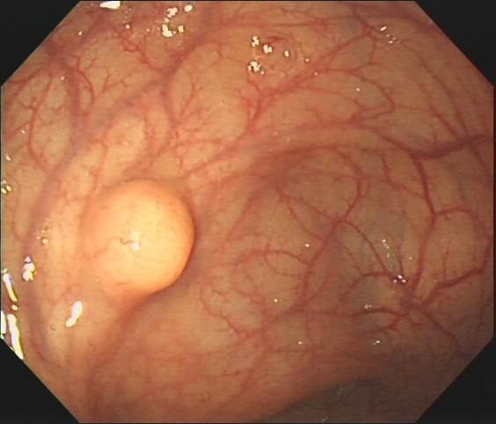

Box

Flat Pedicle Edge

**267 97 72**

**206 200 206**

**353 224 199**

**350 336 419**

Want **categroy**

√

Need **Clinician**

**clinician**

**clinician**

Less

**money**

More **money**

**（b）Our Weakly Supervised Work**

**Our**

**Model**

WSPD



**Flat:77%**

**Pedicle:89%**

**Edge:91%**



**Polyp:67%**

**Polyp:73%**

**Polyp:61%**

**Predict**

**Predict**

**Train**

Flat Pedicle Edge

**Annotated**

**Annotated**

**Image**

**Class**



**Supervised**

**Supervised**

√

**×**

**FSOD**

**Model**

Yolo

Faster-rcnn

et.al.



**（b）Our Method**

**Annotate**

**Train & Predict**

**Train & Predict**

**Supervise**

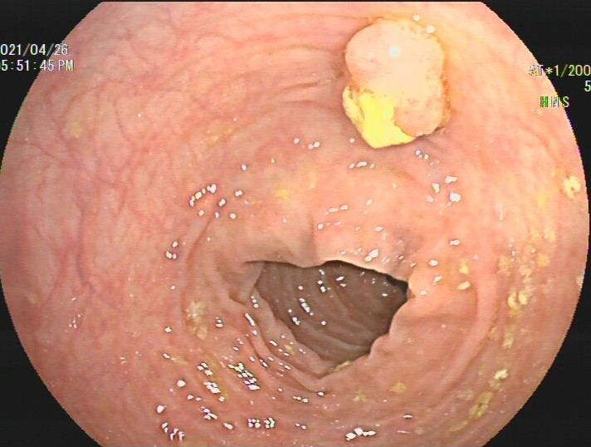

**Image**

**Class**

**Xmin**

**Ymin**

**Xmax**

**Ymax**



Box

Pedicle Pedicle Edge

415 97 72

17 200 206

540 224 199

166 336 419

**FSOD Model**



**Pedicle:67%**

**Pedicle:73%**

**Edge:61%**



Pedicle Pedicle Edge



**Image**

**Class**



**Our Model**



**Pedicle:67%**

**Pedicle:73%**

**Edge:61%**



**（a）Traditional Method**

**Annotate**

**Supervise**

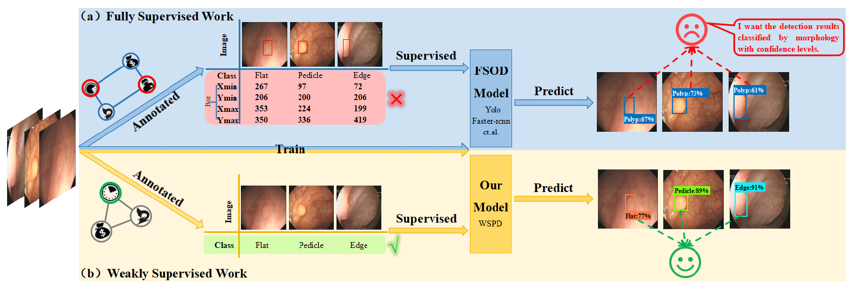

**Class**

**Xmin**

**Ymin**

**Xmax**

**Ymax**

Flat Pedicle Edge

**267 97 72**

**206 200 206**

**353 224 199**

**350 336 419**

**Class**

Flat Pedicle Edge

**（b）Our Weakly Supervised Work**

**Our**

**Model**

WSPD

**FSOD**

**Model**

Yolo

Faster-rcnn

et.al.

FSOD

Model

Yolo

Faster-rcnn

et.al.